Name_______________________________ Date_____________ Fall Picture
 | - Two lines that intersect to form right angles are ___________________.  - If your answer is Adjacent make the eyes on the pumpkin like this:  - If your answer is Perpendicular make the eyes on the pumpkin like this:  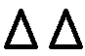 | - A(n) _______________ triangle has 2  congruent sides.  - If your answer is isosceles make the nose on the pumpkin like this:  - If your answer is scalene make the nose on the pumpkin like this:
- ________________ is the point of the line segment that divides it into two congruent segments.  - If your answer is an angle bisector make the mouth on the pumpkin like this:  - If your answer is midpoint make the mouth on the pumpkin like this: |  | - __________ angles are always larger  - If your answer is obtuse color the pumpkin orange.  - If your answer is acute color the pumpkin yellow.  than Right angles.
- An equilateral triangle has 3 ________ sides.  - If your answer is congruent color the top of the tree green.  - If your answer is different color the top of the tree orange. |  | - __________ angles are congruent.  - If your answer is straight draw 5 red apples in the tree.  - If your answer is vertical draw 3 red apples in the tree.
Answer the following questions and create the fall picture.

 | - __________ triangles have three different angles.  - If your answer is scalene color the trunk of the tree dark brown.  - If your answer is isosceles color the trunk of the tree green. | - ____________ triangle is a triangle with 3 acute  angles.  a)If your answer is acute draw 4 acorns at the base of the tree trunk.  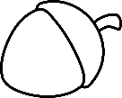  b)If your answer is right draw this bird in the tree.  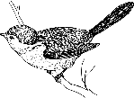
- ________________ angles add to 90 degrees.  a)If your answer is complementary draw this tiny squirrel in the tree hole.  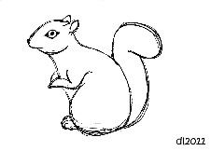  b)If your answer is supplementary leave the tree hole empty. |  | 10. A pentagon had _________ sides  a)If your answer is ten make a sun in the top right corner.  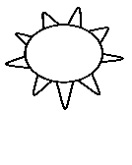  b)If your answer is five make a cloud in the top right corner.
- Intersecting lines form congruent _________ angles.  - If your answer is obtuse write “Autumn is Awesome” in the top left corner of picture.  - If your answer is vertical write “Fall is Fun” in the top left corner of picture. |  | - The exterior angles of a polygon add to _________  degrees.  - If your answer is 360 draw 10 leaves on the ground like this:  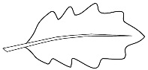  - If your answer is 180 draw 3 squirrels on the ground like this.  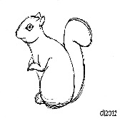

Grading Rubric: 12 points total. 1 point deduction for each incorrect question.

